**AWS Login screen with username :**

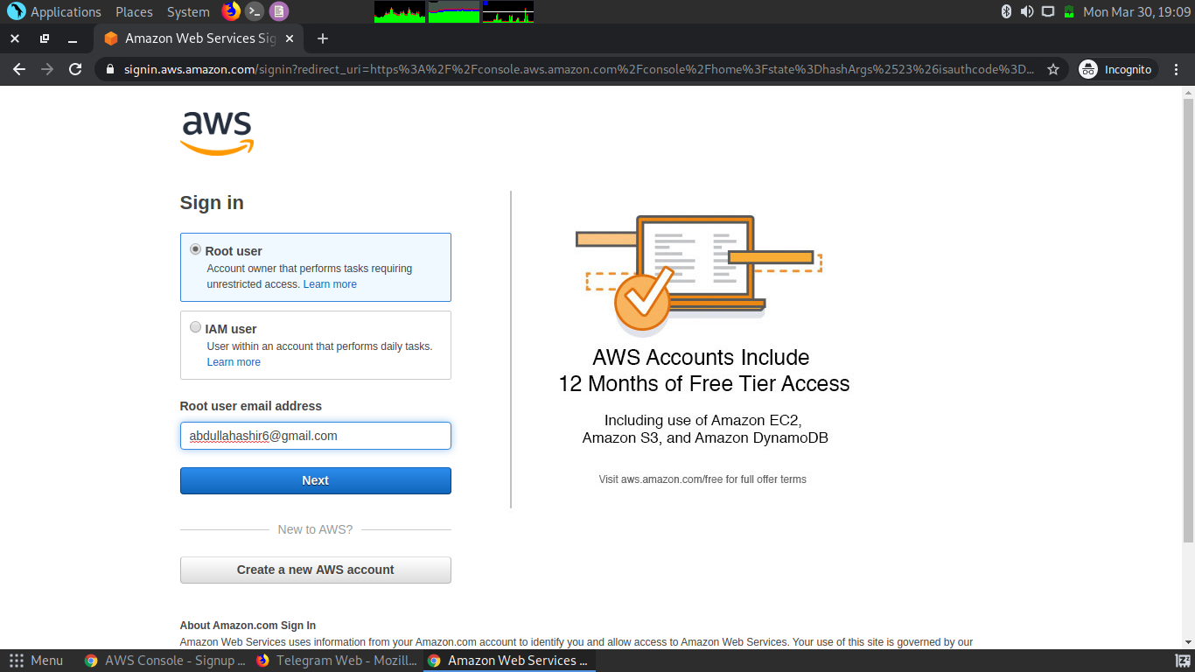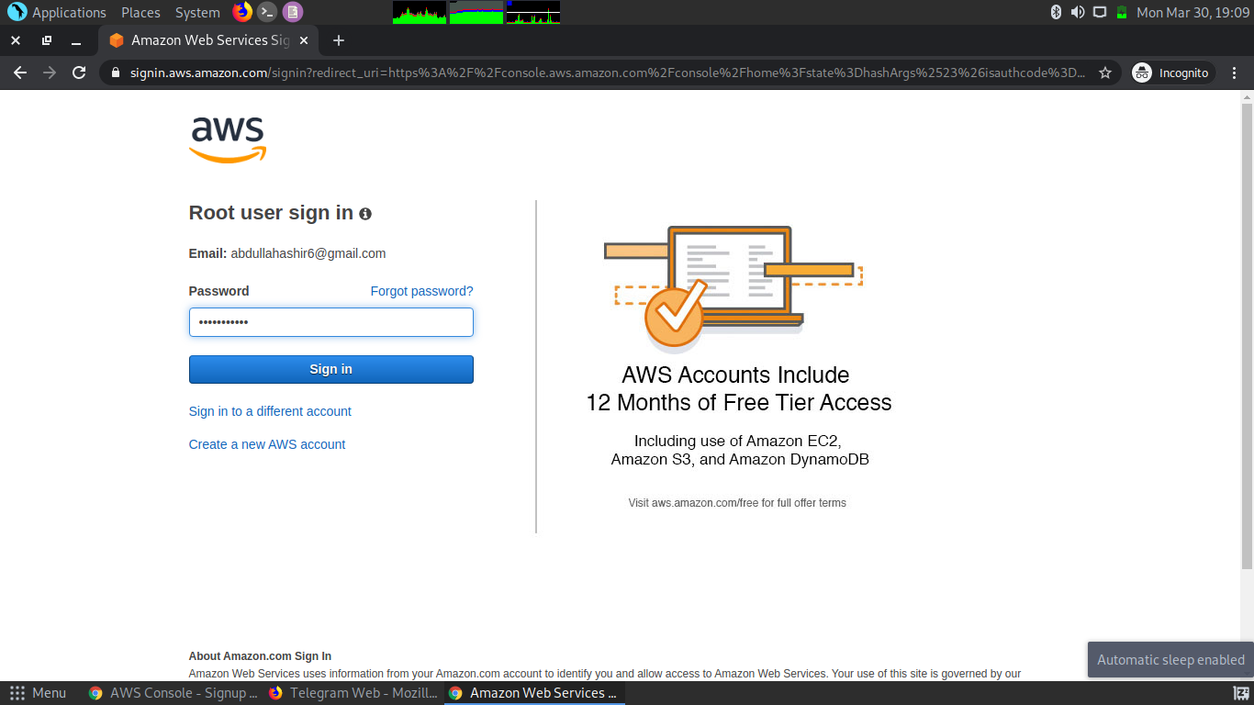.

**EC2 Dashboard :**

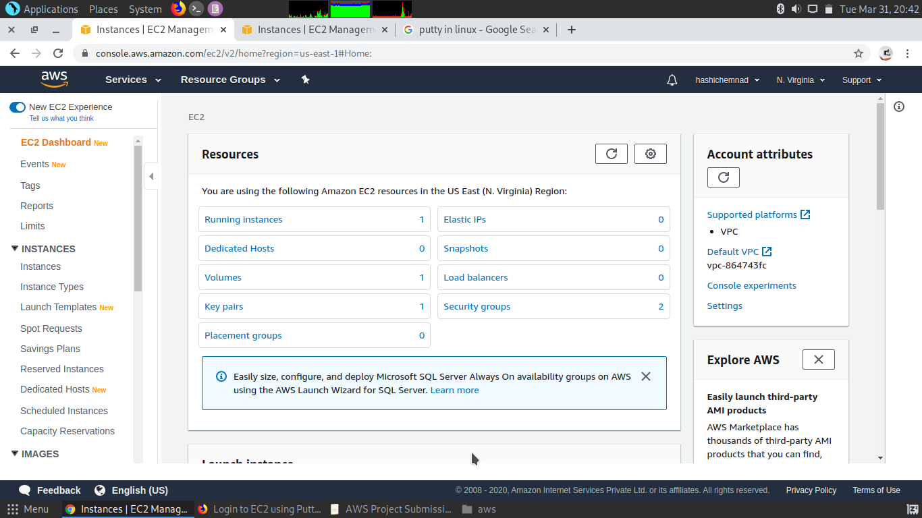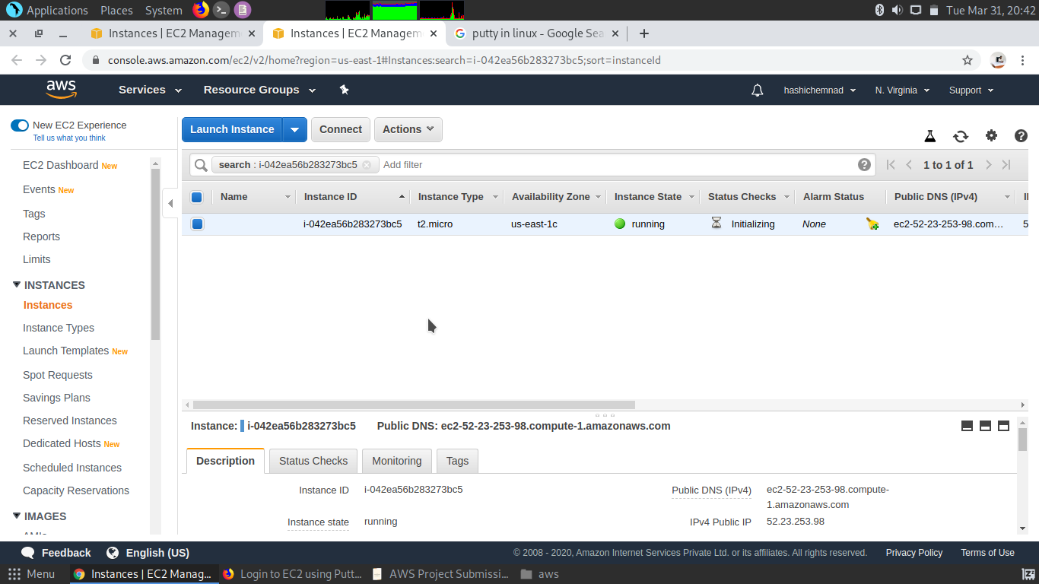**.**

**S3 Dashboard :**

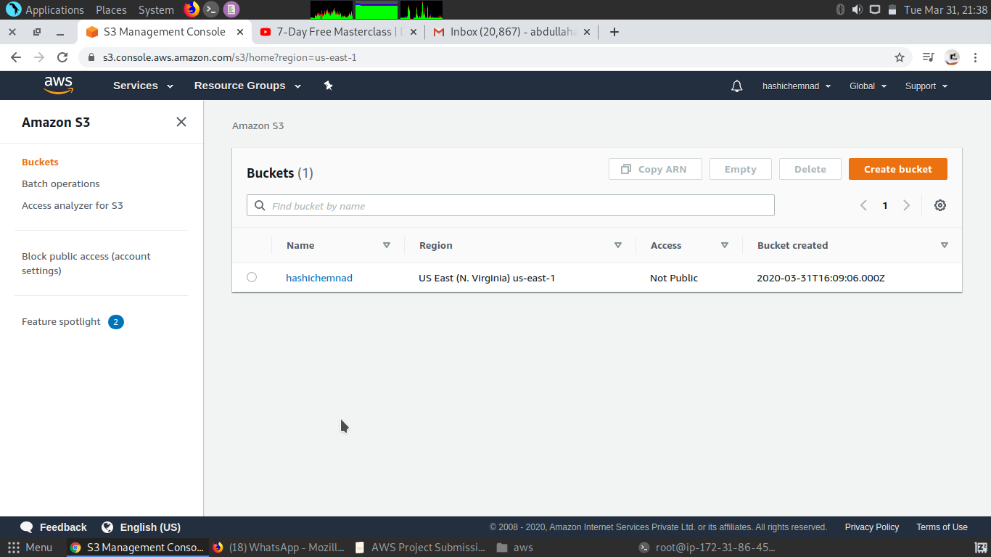**.**

**Rekognition Dashboard :**

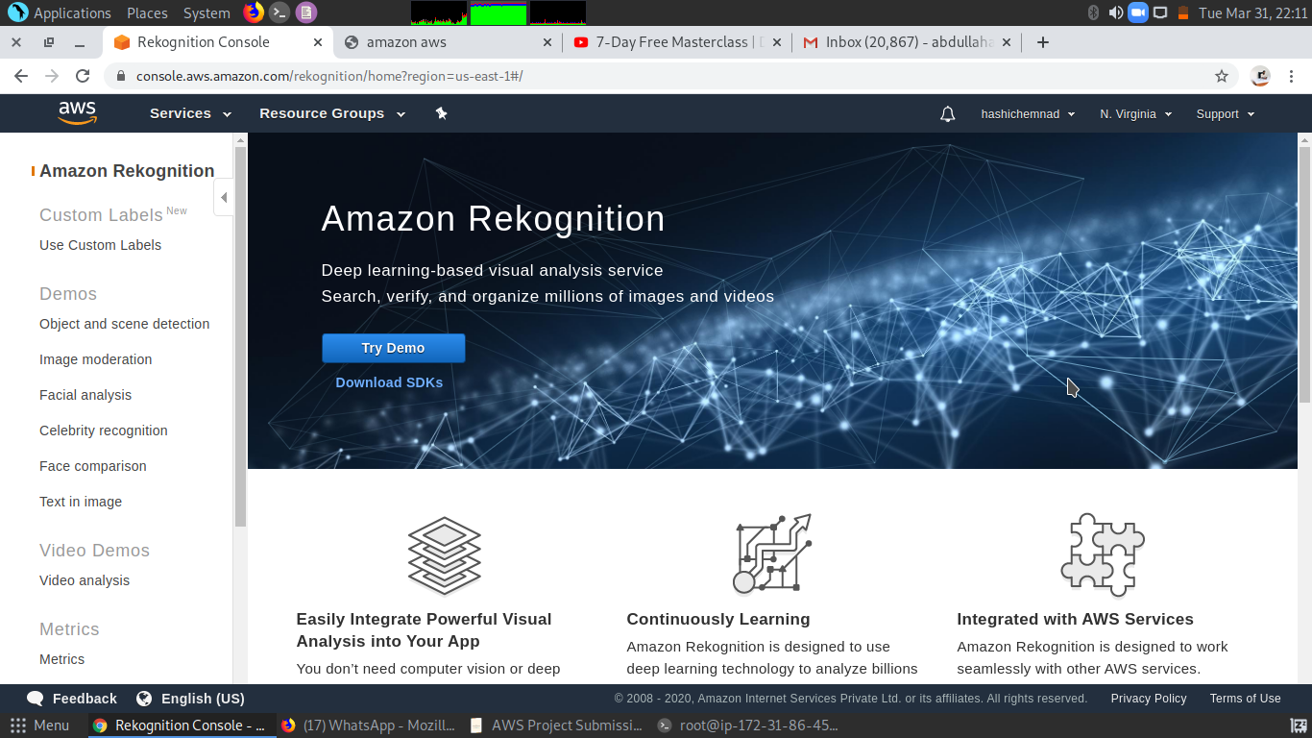**.**

**Screenshots needed for EC2 :**

**Choosing an AMI :**

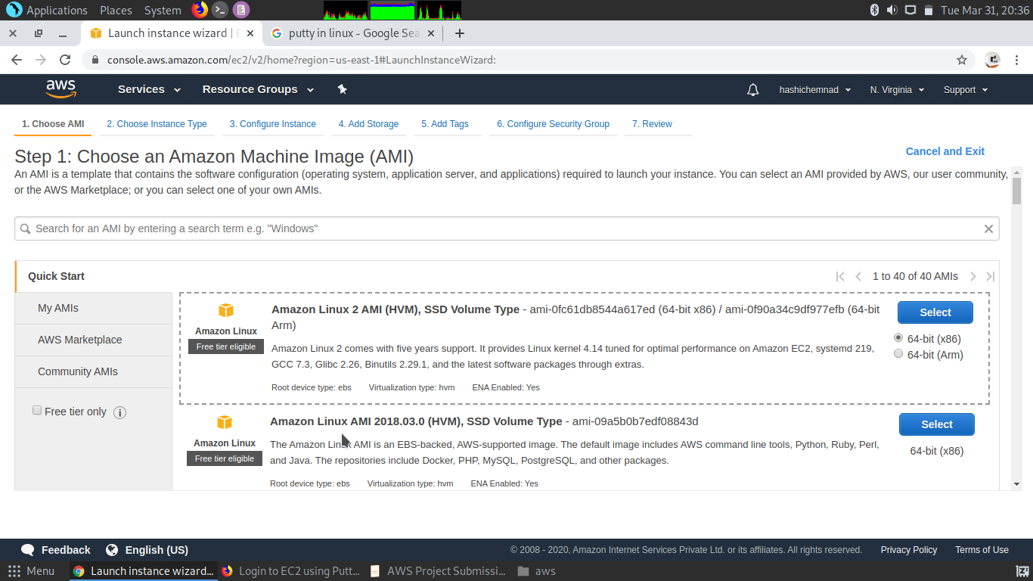**.**

**Choosing an Instance Type :**

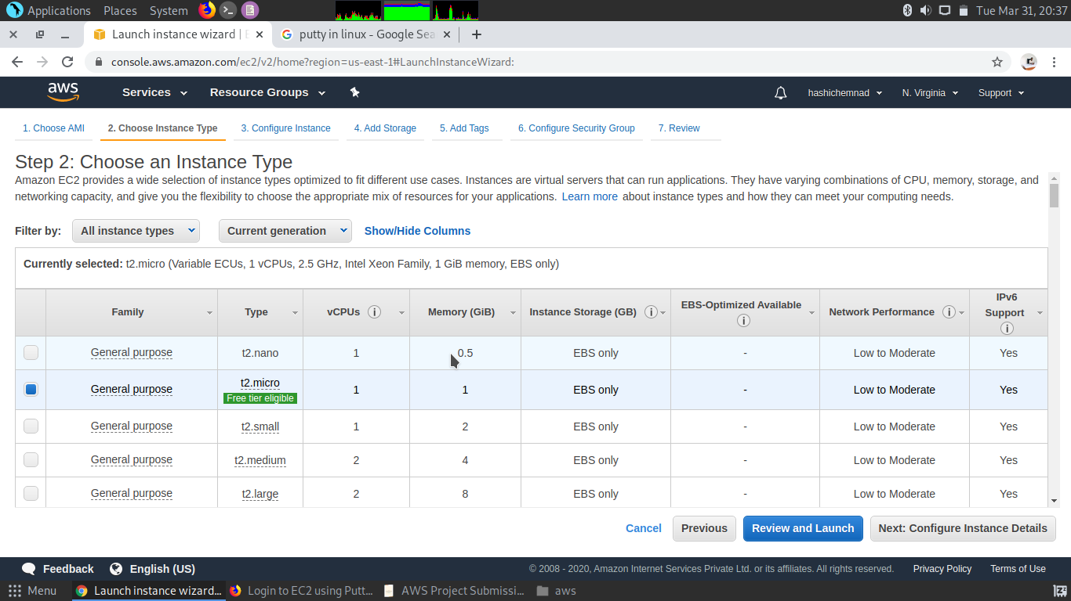**.**

**Adding Storage :**

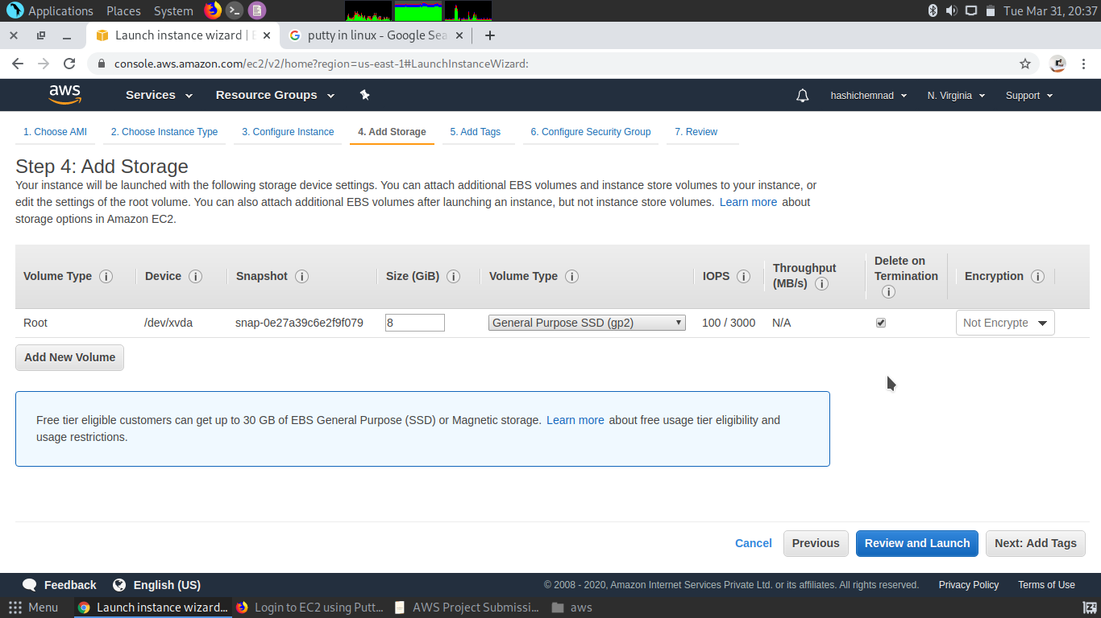**.**

**Configuring Security Group :**

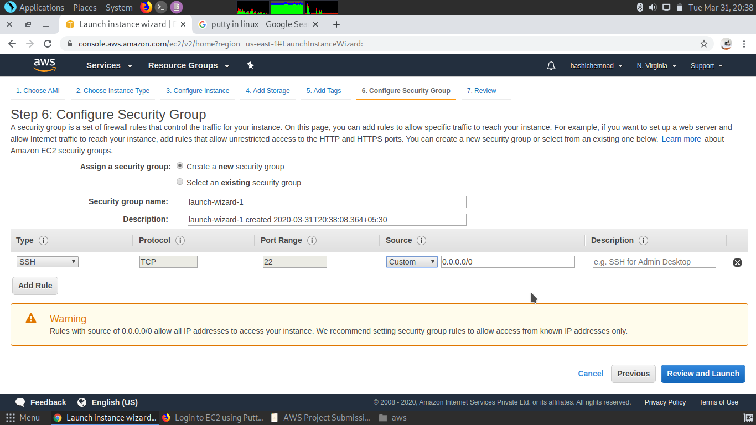**.**

**Key Pair Download :**

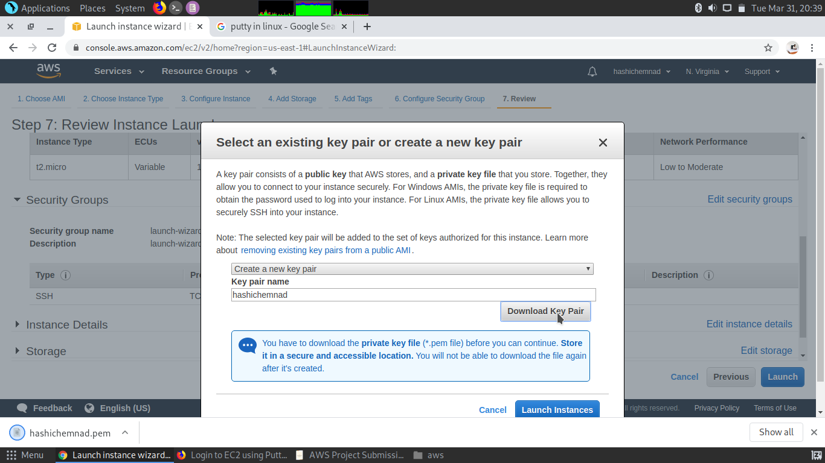 **.**

**Logged in EC2 black screen :**

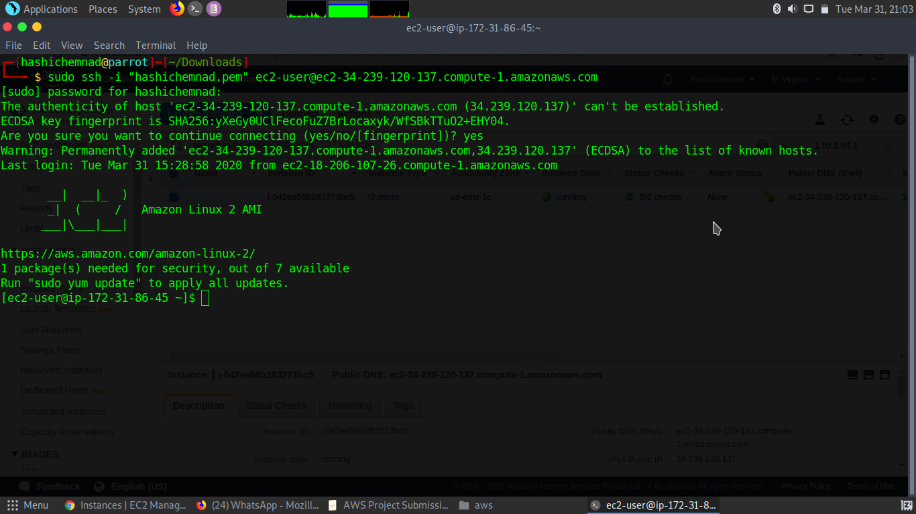**.**

**Screenshots needed for S3 :**

**Creating a bucket:**

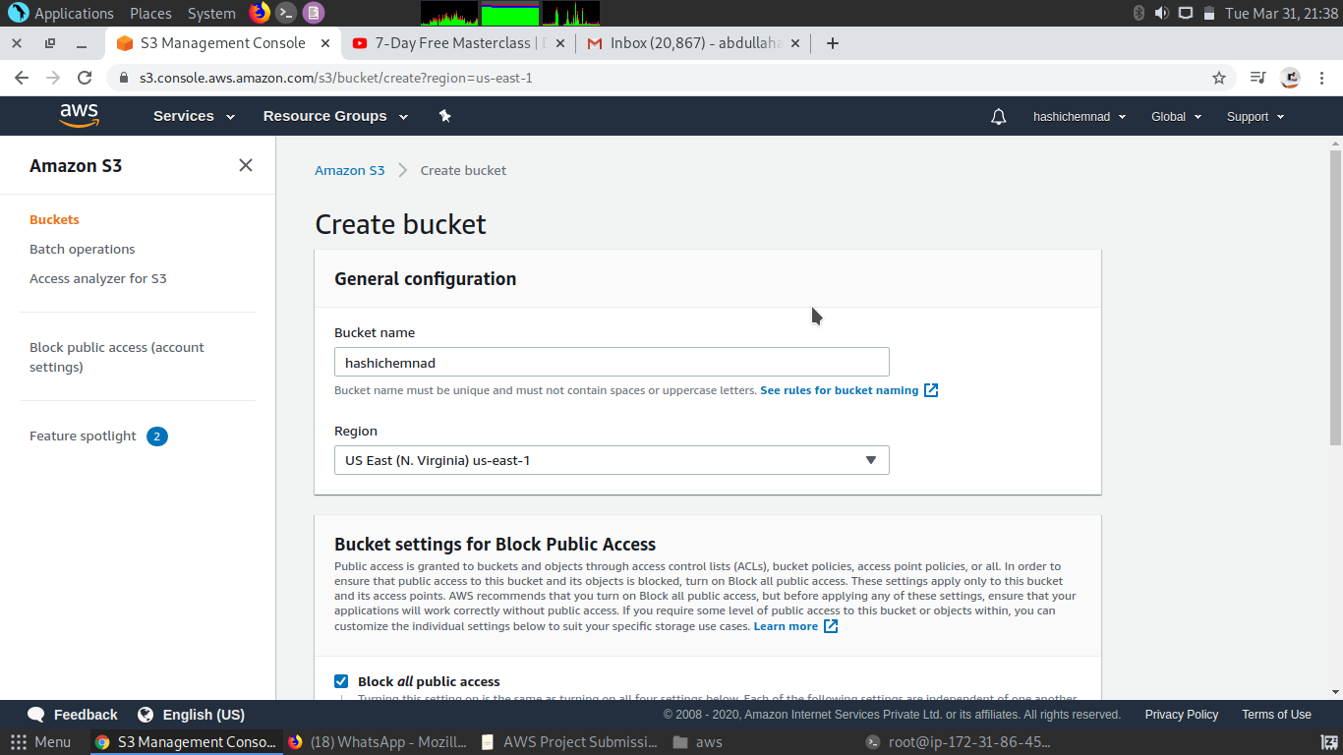

**.**

**Uploading an Object :**

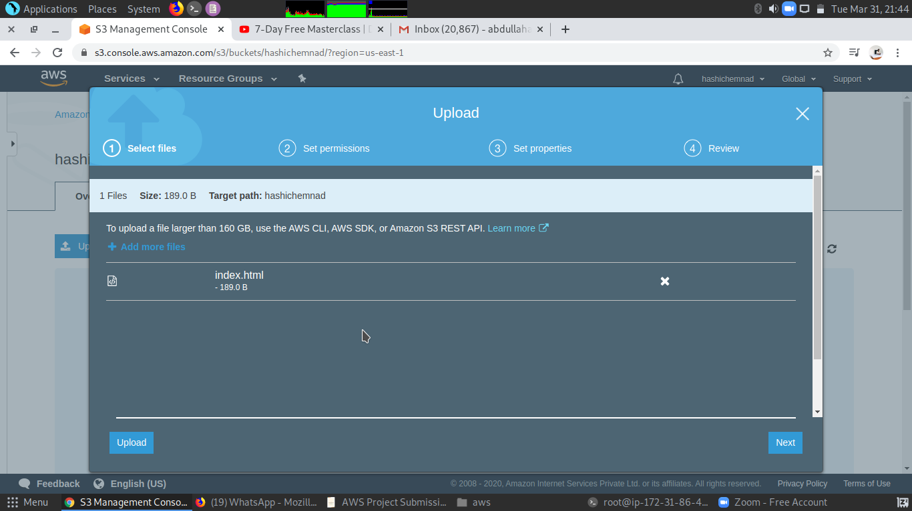**.**

**Enabling Static Website :**

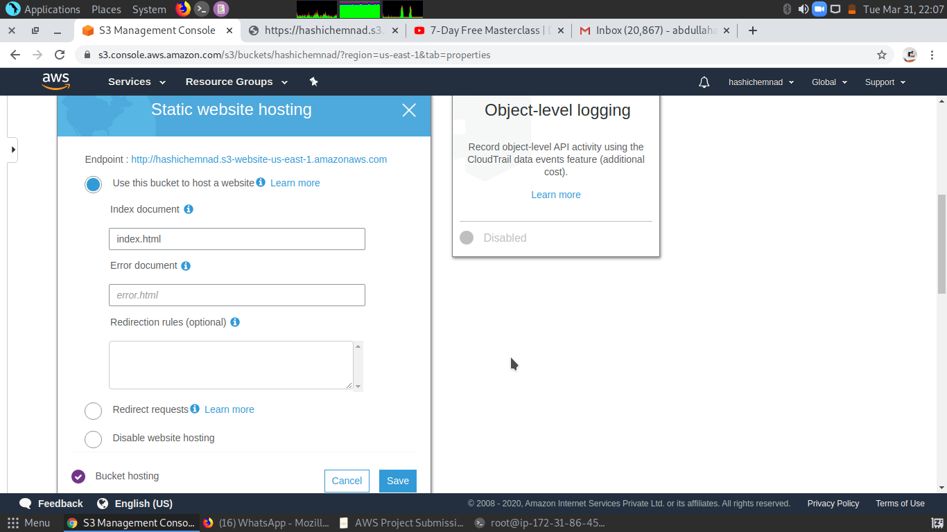 **.**

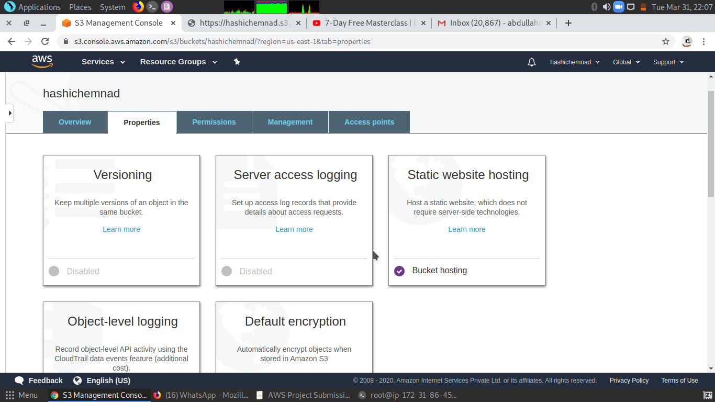

**Making the Object Public**

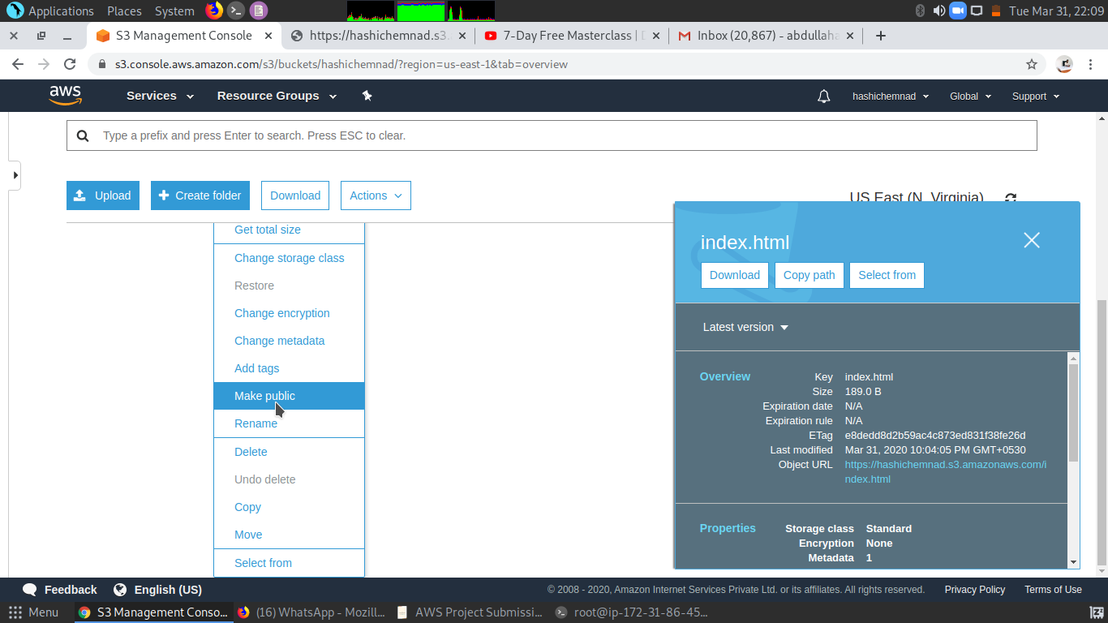**.**

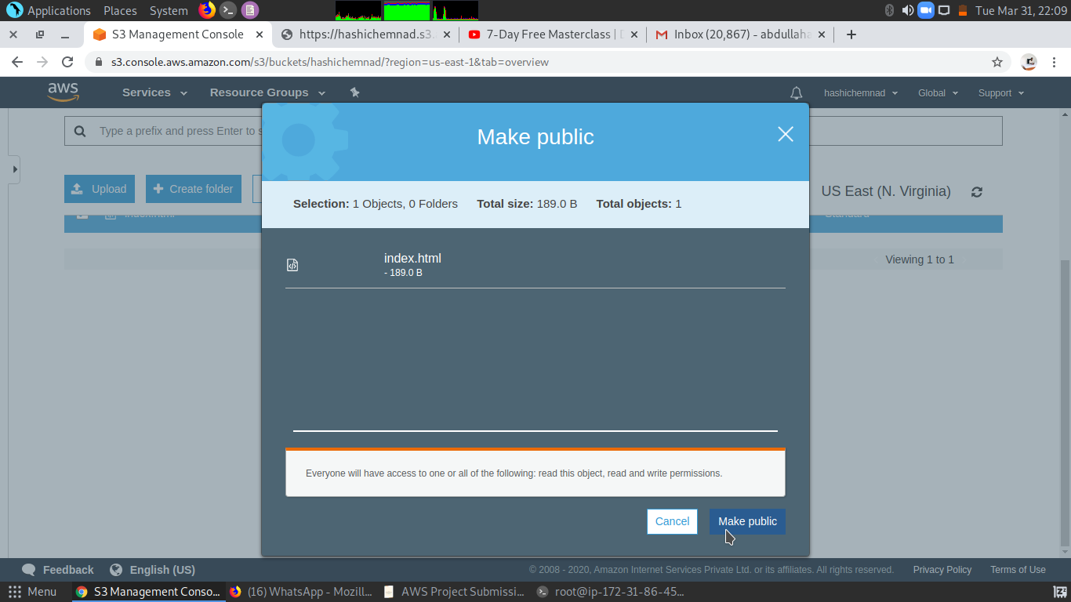**.**

**Checking the S3 link on the browser :**

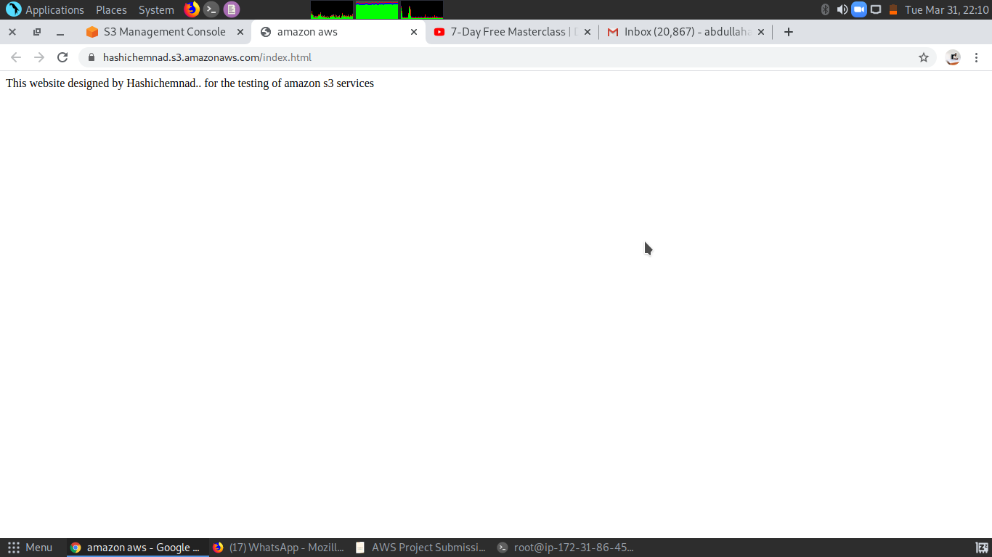**.**

**Screenshots needed for Rekognition :**

**Face Detect :**

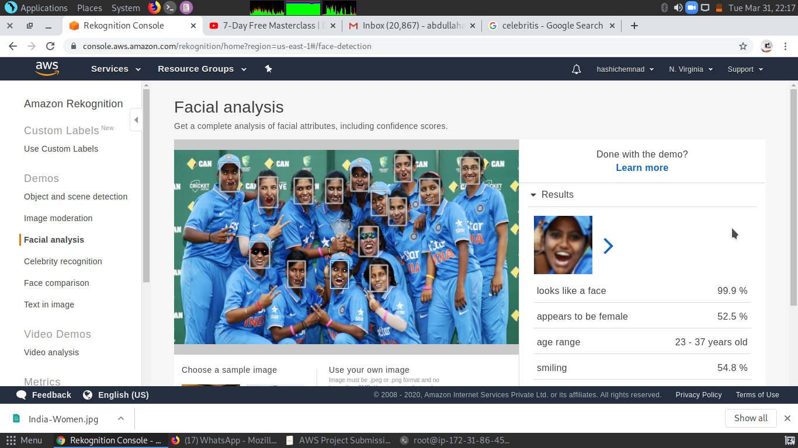**.**

**Face Compare :**

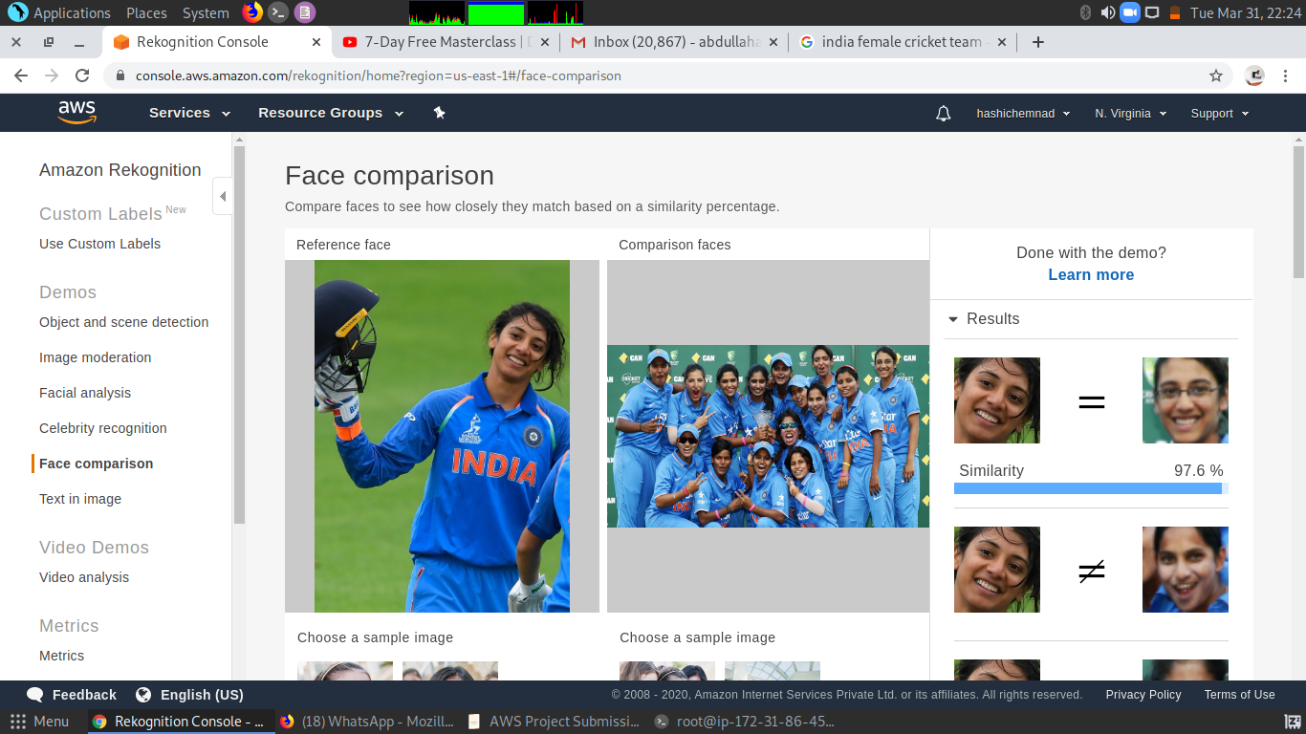**.**

**Celebrity Recognition :**

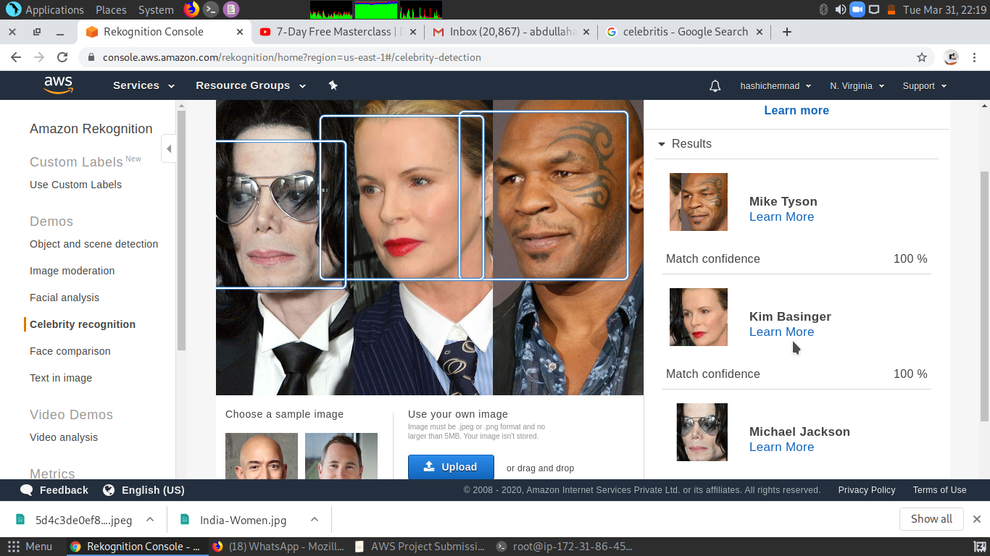**.**

**Text in Image :**

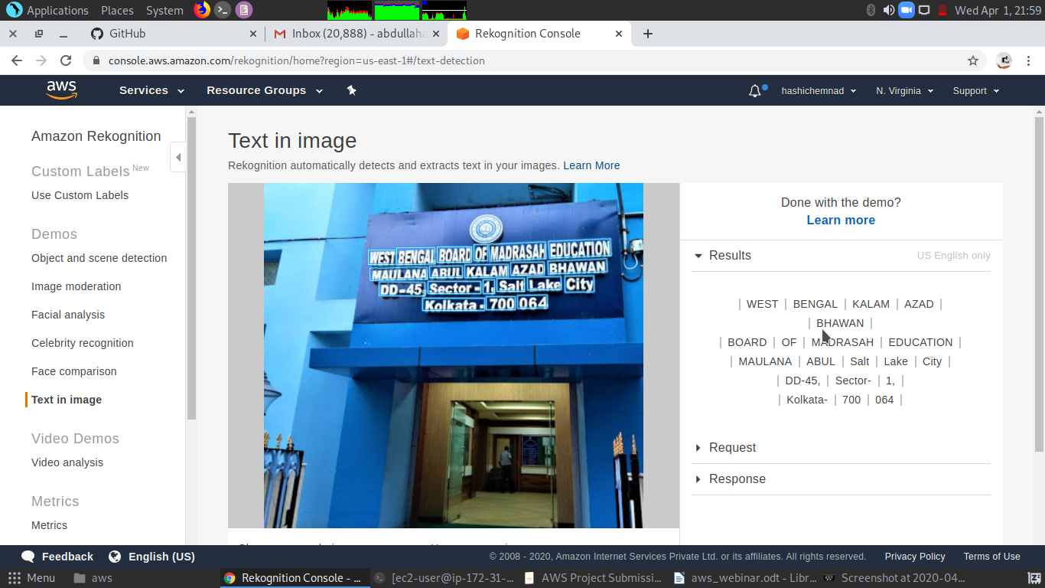**.**

**Screenshots needed for EC2 & S3 :**

**Installing aws-sdk:**

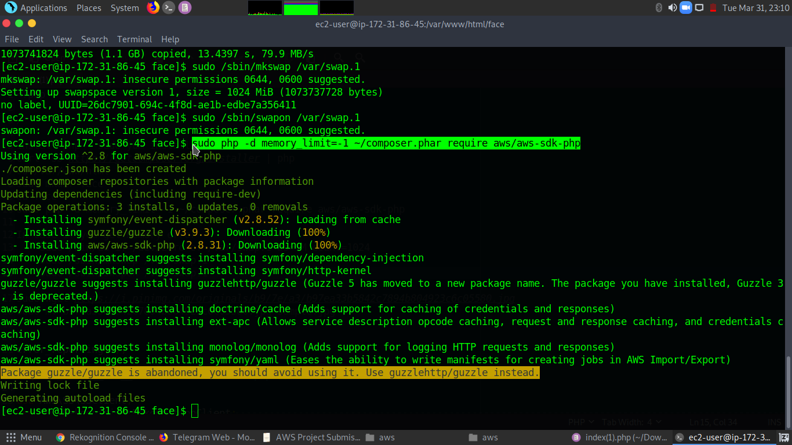**.**

**Installing php :**

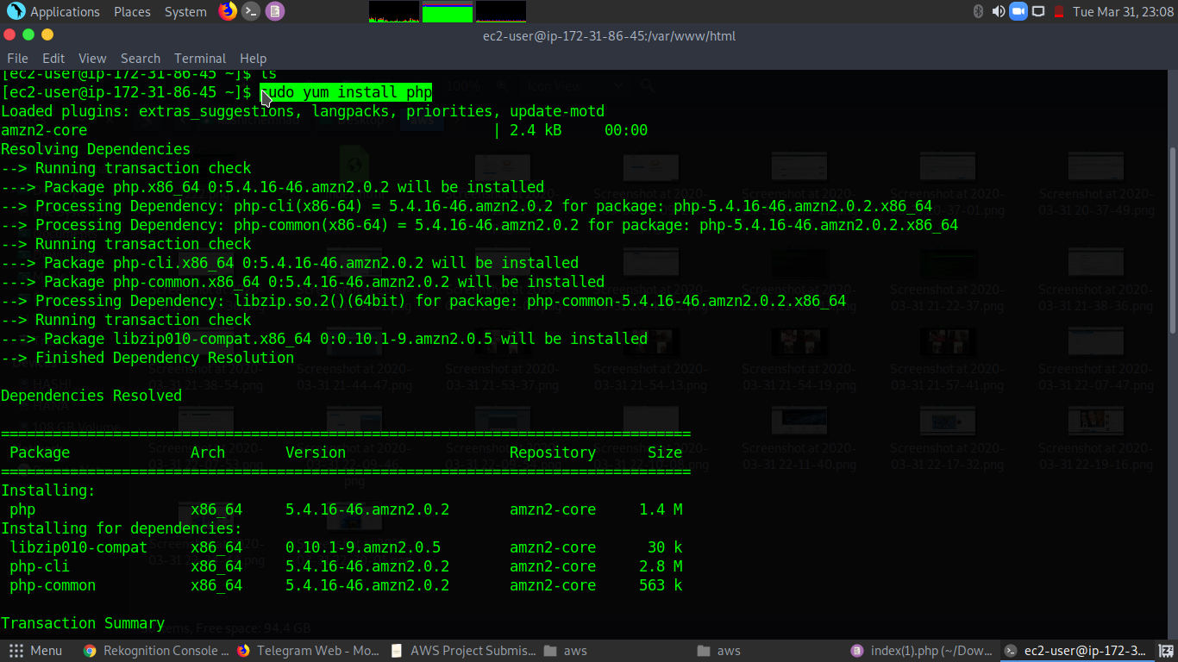**.**

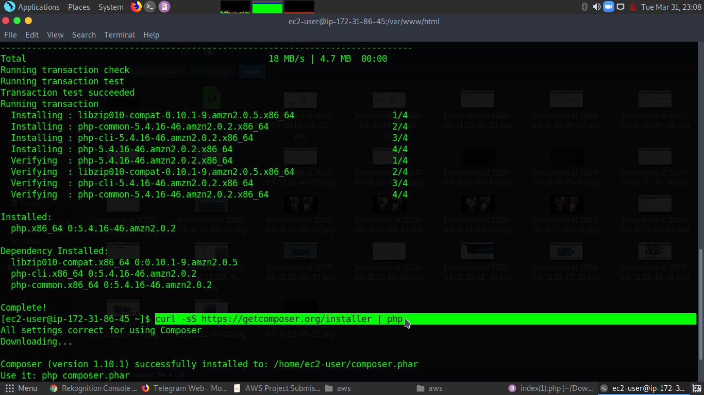

**.**

**index.php file code :**

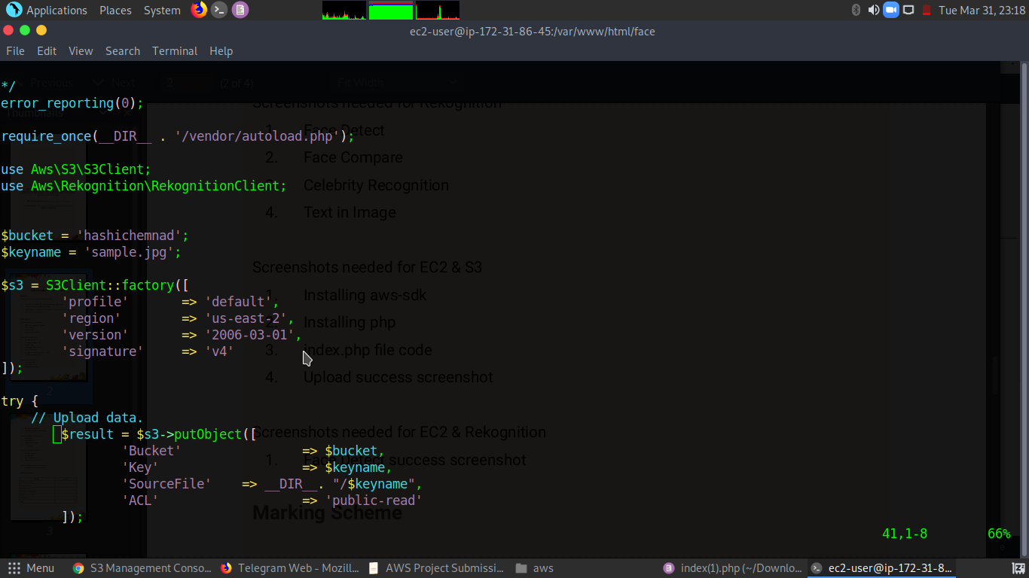**.**

**Upload success screenshot :**

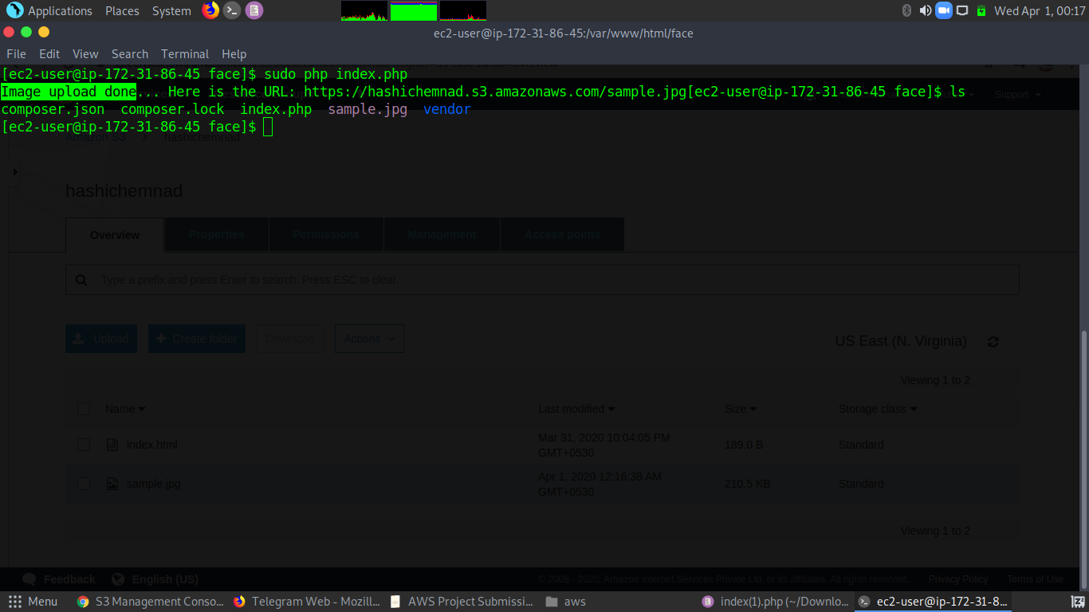**.**

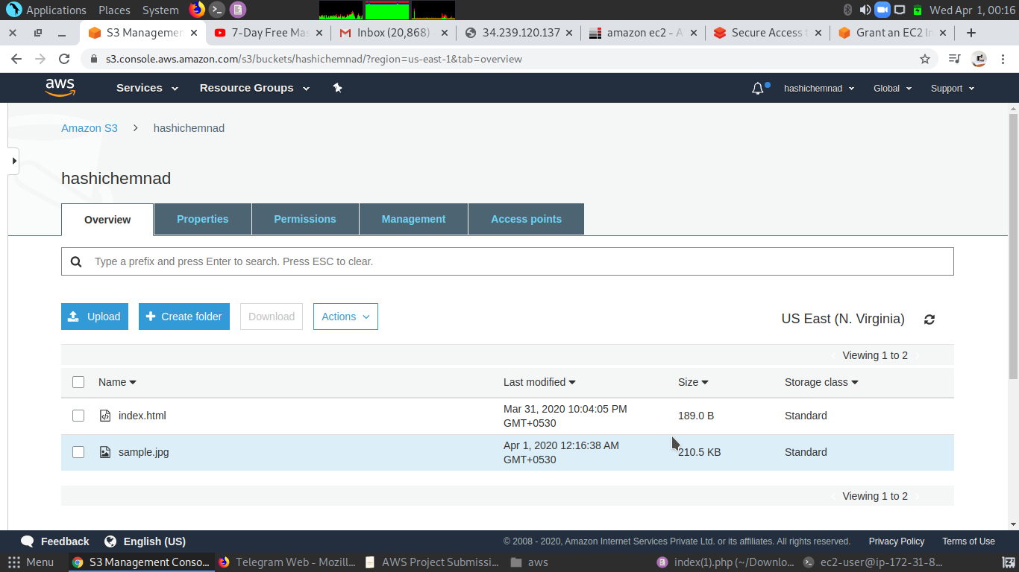**.**

**Screenshots needed for EC2 & Rekognition :**

**Face Detect success screenshot :**

